MERCURY  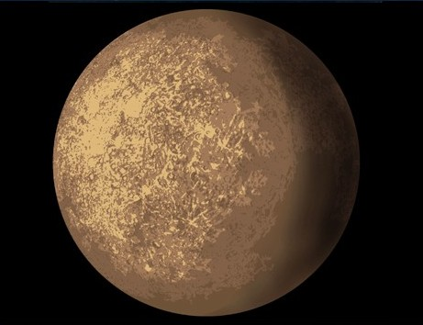  Temperature: 427 °C  Distance from Sun: 56.9 Million Km  Diameter: 4878Km  Number of moons: 0  Tilt: 1°  Rotation Time: 58.7 Earth Days  Orbit Time: 88.0 Earth Days | VENUS  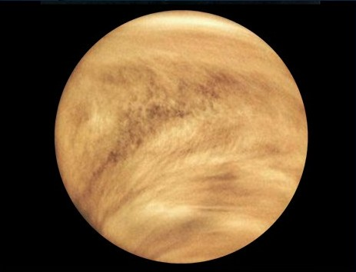  Temperature: 482 °C  Distance from Sun: 108.2 Million Km  Diameter: 12104Km  Number of moons: 0  Tilt: 177°  Rotation Time: 243 Earth Days  Orbit Time: 224.7 Earth Days | EARTH  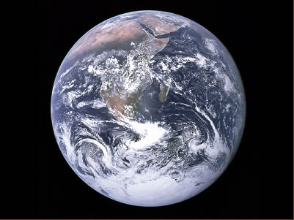  Temperature: 15 °C  Distance from Sun: 149.6 Million Km  Diameter: 12756Km  Number of moons: 1  Tilt: 23°  Rotation Time: 1 Earth Day  Orbit Time: 365.25 Earth Days
MARS  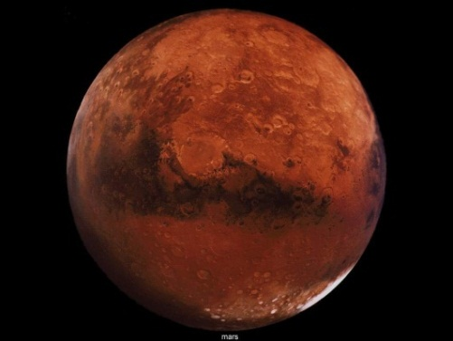  Temperature: -23 °C  Distance from Sun: 227.9 Million Km  Diameter: 6794Km  Number of moons: 2  Tilt: 25°  Rotation Time: 24.6 Hours  Orbit Time: 687.0 Earth Days | JUPITER  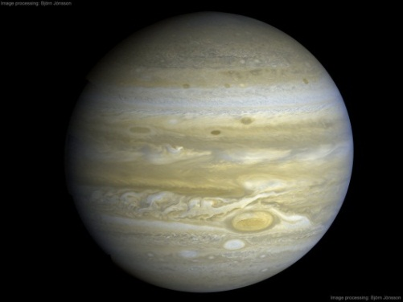  Temperature: -150 °C  Distance from Sun: 778 Million Km  Diameter: 142,800Km  Number of moons: 18+  Tilt: 3°  Rotation Time: 9.84 Hours  Orbit Time: 4332 Earth Days | SATURN  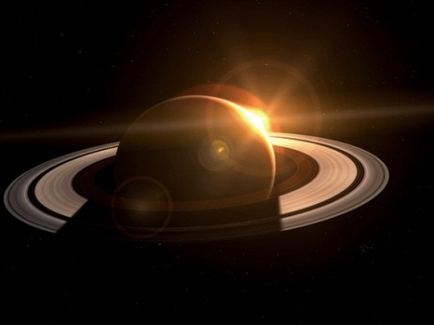  Temperature: -180 °C  Distance from Sun: 1427 Million Km  Diameter: 120536Km  Number of moons: 18+  Tilt: 27°  Rotation Time: 10.2 Hours  Orbit Time: 10760 Earth Days
URANUS  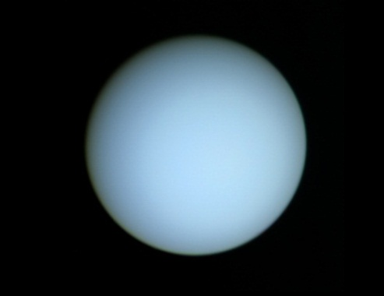  Temperature: -214 °C  Distance from Sun: 2870 Million Km  Diameter: 51118Km  Number of moons: 15  Tilt: 98°  Rotation Time: 17.9 Hours  Orbit Time: 30700 Earth Days | NEPTUNE  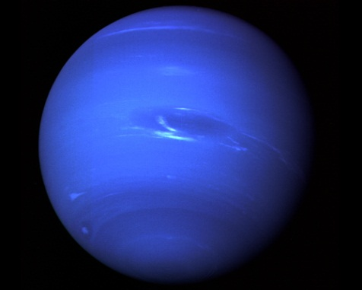  Temperature: -220 °C  Distance from Sun: 4497 Million Km  Diameter: 50538Km  Number of moons: 2  Tilt: 30  Rotation Time: 19.1 Hours  Orbit Time: 60200 Earth Days | PLUTO  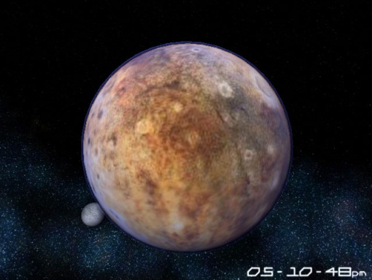  Temperature: -230 °C  Distance from Sun: 5900 Million Km  Diameter: 2324Km  Number of moons: 3  Fact: A dwarf planet  Rotation Time: 6.39 Earth Days  Orbit Time: 90600 Earth Days

