Addition – Year Five
Term | Definition | Example
add, addition, plus | Join groups to find a total
More, increase | Make or become bigger | 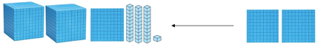
sum | The result of adding numbers together | 3528 + 2947 = 6475
altogether | Counting all the objects and finding the total | 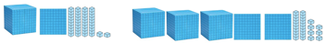  4369
double | Adding a number to itself | 3000 + 3000 = 6000  1225 + 1225 = 2450
Term | Definition |  | Example
near double | Adding a number to the number that is one digit more or one less |  | 3000 + 4000  3000 + 3000 + 1000 = 7000  4000 + 4000 – 1000 = 7000
Instructional Language
Place, arrange |  | Change over split
Rearrange, change |  | Separate
Essential Knowledge

Add multiples of 10, 100, 1000 and tenths | Understanding the effect of adding 10s, 100s, 1000s and tenths to numbers.  e.g. 300 + 256 = 556  2000 + 4239 = 6239  1848.5 + 0.3 = 1848.8 |  |  | Adjust numbers to add | 5469 + 3243 = 8712  5500 -31 + 3250 -7  5500 + 3250 – 38  8750 – 38 = 8712
Fluency of 2-digit + 2-digit numbers with decimals | Able to add 2 two-digit numbers together with rapid recall including decimals.  34 + 54 = 88. 29 + 57 = 86  4.3 + 2.5 = 6.8 0.37 + 0.55 =0.92 |  |  | Use number facts, bridging and place value | 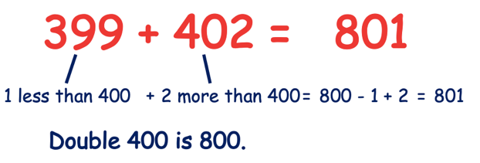  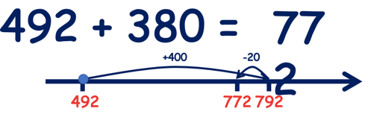
Partition second number to add | 2658 + 263 = 2921  2658 + 200 + 60 + 3  2858 + 60 + 3  2918 + 3  2921 | 24.8 – 5.4  24.8 – 5 = 19.8  19.8 – 0.4 = 19.4
Partition and recombine | 4376 + 2846  4000 + 200 + 100 + 70 + 6  2000 + 800 + 30 + 10 + 2 + 4  6000 + 1000 + 100 + 100+ 10+ 10 + 2  7000 + 200 + 20 +2 = 7222

