Addition – Year Three
Term | Definition | Example
add, addition, plus | Join groups to find a total
more | Make or become bigger | 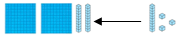
sum | The result of adding numbers together | 543 + 453 = 996
altogether | Counting all the objects and finding the total | 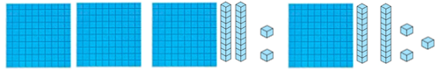  445
double | Adding a number to itself | 30 + 30 = 60 70 + 70 = 140
Term | Definition |  | Example
near double | Adding a number to the number that is one more or one less |  | 30 + 40 = 70 70 + 60 = 130
Instructional Vocabulary
Give an example of… |  | Explain your method/ how you got your answer…
Show how you… |  | Show your working
Essential Knowledge

Add multiples of 10 and 100 | Understanding the effect of adding 1s, 10s and 100s to numbers.  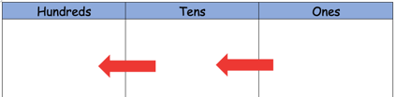  e.g. 46 + 30 = 76  20 + 67 = 87  300 + 256 = 556  428 + 100 = 528 |  | Pairs of numbers to 100  Compliments to 100 | Know all the pairs of numbers that make 100  e.g. 74 + 23 = 100 52 + 48 = 100  82 + 18 = 100 31 + 69 = 100  100 = 62 + 38 100 = 45 + 55  100 = 29 + 71 100 = 36 + 64
Add near multiples of 10 and 100 by rounding and adjusting | Round number to the nearest ten to help addition. Then adjust back.  33 + 29 = 33 + 30 – 1 = 63 – 1 = 62  403 + 542 = 400 + 3 + 542 = 942 + 3 = 945 |  | Partition second number to add | 258 + 163 =  163 = 100 + 50 + 10 + 2 +1  258 + 100 + 50 + 2 + 10 + 1  300 + 100 + 10 + 10 + 1 = 421
Add a single digit by bridging through boundaries | Add a one digit number by jumping to nearest 10 or 100 and then adding on the remaining ones. E.g.  228 + 2 +5 = 230 + 5 = 235  228 + 7 = |  | Add by partitioning and recombining | e.g. 567 + 199 = 766  500 + 60 +7 + 100 + 90 + 9
Use near doubles to add | e.g. 13 + 14 =  13 + 13 + 1 = 26 + 1 = 27  14 + 14 -1 = 28 – 1 = 27

