Term | Definition | Example
Lots of, groups of | Equal groups of amounts | 7 lots of 5 = 35
X, times, multiply, multiplied by | Combining sets of equal groups  Repeated addition | 5 + 5 + 5 + 5 + 5 + 5 + 5 = 35  7 lots of 5 = 35  7 x 5 = 5
Repeated addition | Counting equal groups in 2s, 5s or tens | 5 + 5 + 5 + 5 = 20
Product | The result of multiplying two numbers together | 4 X 8 = 32  product
Array | Rectangular arrangements to show equal groups | 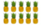
Column | Objects lined top to bottom.  Objects lines form left to right | Column. Row
Row
Term | Definition |  | Example
Double | Total of two sets of the same amount |  | Double 455 = 910
Half | Divide the amount into two equal sets. |  | Half of 866 = 433
Multiple | What is created after multiplying the number by a whole number. |  | 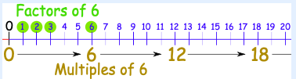
Factor | What is multiplied to get the number
Prime | Numbers that have only 2 factors: 1 and themselves. |  | The first 5 prime numbers are 2, 3, 5, 7, and 11.
Composite | Numbers with more than 2 factors |  | 16 has factors 1, 2, 4, 8, 16
Instructional Vocabulary
Carry on, Continue, Repeat |  | Describe the pattern, describe the rule
What comes next? Predict |  | Find, find all
Find different |  | Investigate
Multiplication – Year Five
All times tables | 2 x table 7 x table  3 x table 8 x table  4 x table 9 x table  5 x table 10 x table  6 x table 11 x table  12 x table |  | 10, 100, 1000 x smaller | Understanding of place value to make numbers ten, one hundred or one thousand times bigger.  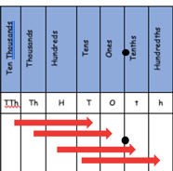  Eg multiplying by 100 the value of digits increases by 100.  1,000 times smaller
100 and 1000 x bigger | Understanding of place value to make numbers one hundred and one thousand times bigger.  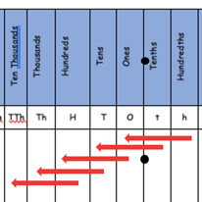  By multiplying by 100 the value of digits increases by 100.  100 times bigger |  | Double larger numbers and decimals | Double = multiply by 2  2,363 doubled = 7,426  8.6 doubled = 17.2  20.22 doubled = 40.44

Essential Knowledge

