Division – Year Two
Term | Definition | Example
Share | Give one object to each group
Share equally | Dividing into equal groups – give one to each numbered group in turn. | 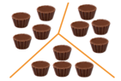
Groups of | Making sets of an agreed number e.g. 5
÷ Divide, division | Making equal parts or groups by sharing or grouping
Divided by | Repeated subtraction from the dividend to group into the divisor | 12 divided by 4 = 3  12 – 4 – 4 – 4 = 0
Division facts (2 x table) | 2 ÷ 2 = 1 14 ÷2 = 7  4 ÷2 = 2 16 ÷2 = 8  6 ÷ 2 = 3 18 ÷2 = 9  8 ÷ 2 = 4. 20 ÷ 2 = 10  10 ÷2 = 5 22 ÷ 2 = 11  12 ÷ 2 = 6 24 ÷ 2 = 12 |  | Halves up to 20 |  | Half of 2 = 1 Half of 12 = 6  Half of 4 = 2 Half of 14 = 7  Half of 6 = 3 Half of 16 = 8  Half of 8 = 4 Half of 18 = 9  Half = 10 = 5 Half of 20 = 10
Division facts (10 x table) | 10 ÷ 10 = 1 70 ÷10 = 7  20 ÷10 = 2 80 ÷10= 8  30 ÷ 10 = 3 90 ÷10= 9  40 ÷ 10 = 4. 100 ÷ 10= 10  50 ÷10 = 5 110÷ 10 = 11  60 ÷ 10 = 6 120÷ 10 = 12 |  | Count back in 3s |  | 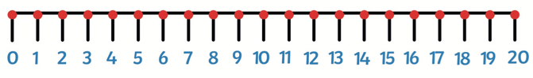  30, 27, 24, 21, 18, 15, ...
Division facts (5x table) | 5 ÷ 5 = 1 35 ÷5 = 7  10 ÷ 5 = 2 40 ÷ 5 = 8  15 ÷ 5 = 3 45 ÷ 5 = 9  20 ÷ 5 = 4. 50 ÷ 5 = 10  25 ÷ 5 = 5 55 ÷ 5 = 11  30 ÷ 5 = 6 60 ÷ 5 = 12 |  | All numbers ending in 5 and 0 will divide by 5 | 5 10 15 20 25 30 35 40 45 50
 |  |  | All numbers ending in 0 will divide by 10. | 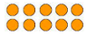  10 20 30 40 50 60 70 80 90 100

Term | Definition |  | Example
Divided into | Sharing the amount equally into a set number of groups |  | 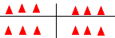
Left over | The amount left over when a number does not divide equally into a set number. |  | 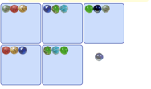
Instructional Vocabulary
Tell me, describe, name, pick out |  | Talk about, explain, explain your method
Explain how you got your answer |  | Give an example of, show me how….
Essential Knowledge

