Division – Year Five
Essential Knowledge

Term | Definition | Example
Equal groups of | Give one object to each group
÷ Divide, division | Dividing into equal groups – give one to each numbered group in turn. | 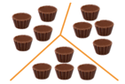
Divided by | Repeated subtraction from the dividend to group into the divisor | 12 divided by 4 = 3  12 – 4 – 4 – 4 = 0
Divided into | Sharing the dividend equally into the divisor | 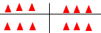
Remainder | The amount left over where one quantity cannot be exactly divided by another.  10 ÷ 3 = 3 remainder 1. | 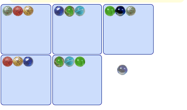  16 ÷ 5 = 3 R 1
Term | Definition |  | Example
Factor | In multiplication the numbers multiplied together are called factors |  | Factor x factor = product  6 x 7 = 42
Quotient | In division the answer when a dividend is divided by the divisor the answer is the quotient |  | 42 ÷ 6 = 7  Quotient
Divisible by | When a number gives a whole number answer |  | 24 is divisible by 1, 2, 3, 4, 6, 8, 12, 24
Inverse | The opposite or reverse of an operation. Division is the inverse of multiplication |  | 6 x 9 = 54  54 ÷ 9 = 6
Instructional Vocabulary
Calculate, work out, solve |  | Investigate, question
Answer, Check |  | Different missing number/s
Number facts, |  | Number pairs, Number bonds
Greatest value |  | Least value
Review division facts for tables learnt so far | Division facts for 7 x table  2 x table 8 x table  3 x table 9 x table  4 x table 10 x table  5 x table 11 x table  6 x table 12 x table |  | 100, 1000 smaller |  | Understanding of place value to make numbers one hundred or one thousand times bigger.  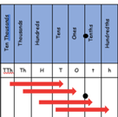  Eg multiplying by 100 the value of digits increases by 100.  1,000 times smaller
Partition to divide mentally | 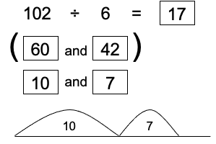 |  | Halve larger numbers and decimals |  | Halve = divide by 2  7, 426 halved = 2,363  17.2 halved = 8.6  40.44 halved = 20.22
Divisibility tests to 2, 3, 5, 6, 10 | 2 Any even number (ending in 0,2,4,6,8) will divide equally by 2  3 Any number with a digit sum of a multiple of 3  5 Any number ending in 0 or 5 will divide equally by 5  6 Any number with a digit sum of a multiple of 3 and is even will divide equally by 6  10 Any number with ending in 0 is a multiple of 10 |  | Any number with a digit sum of a multiple of 9 and will divide equally by 9 | Example: is 723 divisible by 9?  Digit sum: 7 + 2 + 3 = 12  12 ÷ 9 = 9 remainder 3  It does not divide equally by 9 so it is not divisible by 9.  Example: is 8784 divisible by 9?  Digit sum: 8 + 7 + 8 + 4 =  27 ÷ 9 = 3 So 8784 is divisible by 9.

