Spelling Words

Year Five and Six

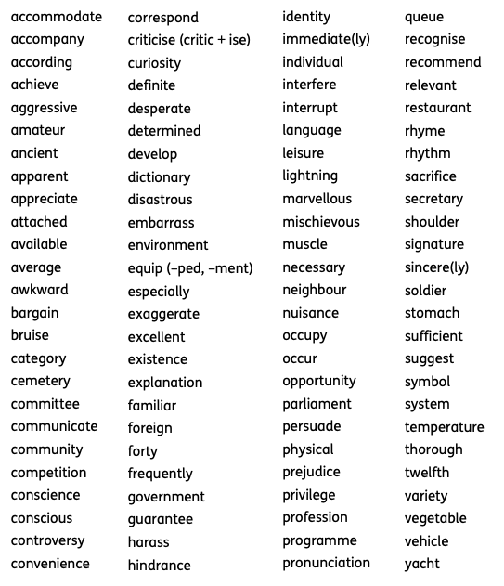
Here are the spelling words that children are expected to be able to spell by the end of year 6. (age 11)

