Addition – Year One

Term | Definition | Example
add | Join groups to find a total | 3 + 2 = 5
more | Make or become bigger
plus | Add | 3 +2 = 5
sum | The result of adding numbers together | 3 + 4 + 2 = 9
altogether | Counting all the objects and finding the total | 6

Term | Definition | Example
double | Adding a number to itself | 3 + 3 = 6 7 + 7 = 14
near double | Adding a number to the number that is one more or one less | 3 + 4 = 7 7 + 6 = 13
equal | The same amount or number
same | Exactly the same amount or value
Essential Knowledge

Find one more | Find one more than numbers to 100.  Number lines and hundred square – find number and jump one to the right.  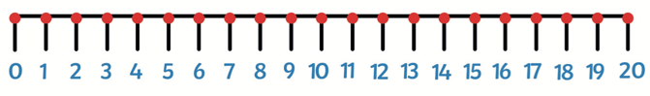 |  | Know doubles to 10 | Recall all doubles to 10  1 + 1 = 2.  2 + 2 = 4  3 + 3 = 6  4 + 4 = 8  5 + 5 = 10
Addition by putting the largest number first | 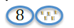  E.g. 8 + 5 = 13  Put the 8 in your head as the bigger number and count on 9,10,11,12,13 |  | Number bonds to 10 | 0 + 10 = 10 6 + 4 = 10  1 + 9 = 10 7 + 3 = 10  2 + 8 = 10 8 + 2 = 10  3 + 7 = 10 9 + 1 = 10  4 + 6 = 10 10 + 0 = 10  5 + 5 = 10
Add ten to a number | Understand that adding ten to a number means there is one ten added to the ten column but the ones column doesn’t change.  e.g. 10 + 7 = 17. 3 + 10 = 13 |  | Use number bonds to ten to work out number bonds to 11 | Work out bond by adding 1 to the larger number. Eg. 1 + 10 = 11  0 + 11 = 11 5 + 6 = 11 10 + 1 = 11  1 + 10 = 11 6 + 5 = 11 11 + 0 = 11  2 + 9 = 11 7 + 4 = 11  3 + 8 = 11 8 + 3 = 11  4 + 7 = 11 9 + 2 = 11
+ add, more, plus, sum
=. equals, same

