Term | Definition | Example  Subtraction – Year Five
subtraction, subtract, minus, take away | To subtract a quantity from another | 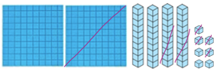  247 – 124 = 123
How many are left/ left over? | Amount left after an amount has been taken away. | 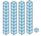  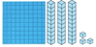  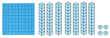  =  -  There are 41 left over.
How many more? | How many more in the greater amount | 825 > 719 (825 – 719 = 106)  825 is 106 more than 719
How much less/ fewer is? | How many less in the smaller amount. | 181 < 325 (325 – 181 = 144)  181 is 144 more than 325
Difference between | The amount between the two amounts. | 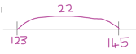  Difference between 123 and 145  is 22
Difference between half | What is the difference between half of a number and half of a number | Half of 526 = 263.  Half of 392 = 196  263 – 196 = 67
Term | Definition |  | Example
= equals | Exactly the same amount or value |  | 400 + 50 + 9 = 459
tens boundary, hundreds boundary | When numbers jump over the multiple of ten or one hundred |  | 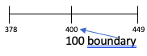
Inverse | Reverses the function  Subtraction reverses addition |  | 164 + 34 = 198 198 – 34 = 164  198 – 164 = 34
exchange | Breaking down hundreds or tens to a lower value e.g.1 ten = 10 ones, 1 hundred = 10 tens |  | =
Carried digits | A digit that is carried from one column value to one of a different value |  | 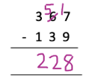  Carried digit
Instructional Vocabulary
Put, place, arrange |  | adjust
Change, change over adjusting |  | Split, separate
Fluency of 2-digit – 2-digit numbers | Able to subtract 2 two-digit numbers together with rapid recall.  96 – 42 = 54 52 – 36 = 16 |  | Subtract multiples of 10, 100,1000 and tenths | 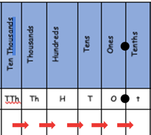  76,636 – 37,435 =  Count back in thousands,  hundreds,tens, ones and tenths.
Difference between | 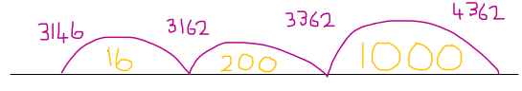  Difference between 4362 – 3146 = 1216  1000 + 100 + 60 + 30 + 26 = 1216 |  | Use number facts, bridging and place value | 36,925 – 15,825 =
Partition the second number to subtract | 52,783 – 32,364 = 52,783 – 3 = 52,780  52,780 – 1 = 52,779 52,779 – 60 = 52,719  52,719 – 300 = 52,419 52,419 – 200 = 50,419  50,419 – 30,000 = 20,419 52,783 – 32,364 = 20,419  323,64  2,0000  30,000  1  3  60  300 |  | Adjust numbers to subtract number | 35, 627 – 23,412 =  (23,412 near multiple is 23,400 + 12)  35,627 – 23,400 = 12,227 – 12 = 12,215  35,627 – 13,400 = 12,215 | 12,645 – 3,954 =  (3,954 near multiple is 4,000 - 46)  12,645 – 4,000 = 8,645  8,645 + 46 = 8,691
Essential Knowledge

78 count back 6 = 72
72 count back 30 = 42

