Year One
This week’s learning: 16th October 2020

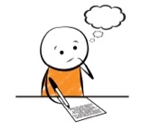  Spellings | Reading | Vocabulary
wing  king  rain  wait  coat  road  the  I | Said  The  I  She  Be  Me  He  We  was | Leaky tap – drops of water are coming out of the tap when it is turned off.  Uncomfortable – Something is causing a bit of pain. It is not comfy.  Exhausted – very tired  Frustrated – feeling upset about something  Annoyed – beginning to feel angry  DON’T FORGET TO READ YOUR READING BOOK EVERY DAY!  SHARE STROIES AND OTHER BOOKS AS OFTEN AS YOU CAN!

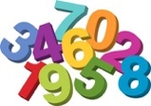  Maths  This Photo by Unknown Author is licensed under CC BY-ND | Times Table Rock Stars  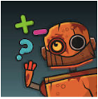  NumBot | Maths and Topic Vocabulary
Practice counting from 0 to 20 and 20 to 0.  Find 1 more than numbers to 10 or 20. Use counters, buttons, beans etc if you need some help. | Colour in a smile each time you practise. | More – a greater or bigger amount. The number or amount gets bigger.  Less – a smaller or fewer amount. The number or amount gets fewer.  Rough – a surface with bumps or holes that is uneven  Smooth - a surface that is not rough.

