Term | Definition | Example  Subtraction – Year Three
Subtraction, subtract, minus, take away | To subtract a quantity from another | 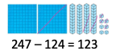
How many are left/ left over? | Amount left after an amount has been taken away. | 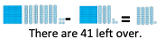
How many fewer? | How many less in the smaller amount | 181 < 325 (325 – 181 = 144)  181 is 144 less than 325
How much less is? | How many less in the smaller amount. | 32 – 18 = 14  18 is 14 less than 18.
Difference between | The amount between the two amounts. | Difference between 123 and 145  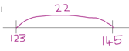  is 22
Term | Definition |  | Example
Half, halve | Making two equal groups |  | Half of 6 is 3
= equals | Exactly the same amount or value |  | 400 + 50 + 9 = 459
Tens boundary, hundreds boundary | When numbers jump over the multiple of ten or one hundred |  | 100 boundary  449  378  400
Exchange | Breaking down hundreds or tens to a lower value e.g.1 ten = 10 ones, 1 hundred = 10 tens |  | =
Carried digits | A digit that is carried from one column value to one of a different value |  | 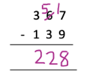  Carried digit
Instructional Vocabulary
Explain your method |  | Explain how you got your answer
Give an example of… |  | Show how you…/ show your working….
Subtract single digit bridging through boundaries | 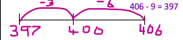  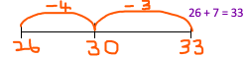  33 – 7 = 26. 406 – 7 = 397 |  | Subtract multiples of 10, 100 | 636 – 435 =  Count back in hundreds,tens, ones understand h t u and subtract 10s from T and 100s from 100scolumn.
Difference between | Difference between 573 and 962  73 + 300 + 62 = 300 + 135 = 435 |  | Pairs to 100  Compliments to 100 | Know all the pairs of numbers that make 100  e.g. 100 – 62 = 38 100 – 91 = 9  100 – 24 = 76 100 – 15 = 85  100 – 79 = 21 100 – 83 = 17
Partition the second number to subtract | 756 – 364 =  364  160  4  756 – 4 = 752 752 – 160 = 592  592 – 200 = 392  200 |  | Subtract near multiples of 10 and 100 by rounding and adjusting | 47 – 29 =  (29 near multiple is 30)  47 – 30 + 1 =  17 + 1 =  18 | 627 - 412 =  (412 near multiple is 400)  627– 400 – 12 =  227 – 12 =  215
Partition and recombine | 625 – 314 =  600 + 20 + 5 – 300 + 10 + 4 = 300 + 10 + 1 = 311
Essential Knowledge

78 count back 6 = 72
72 count back 30 = 42

