Spelling Words

Year Three and Four

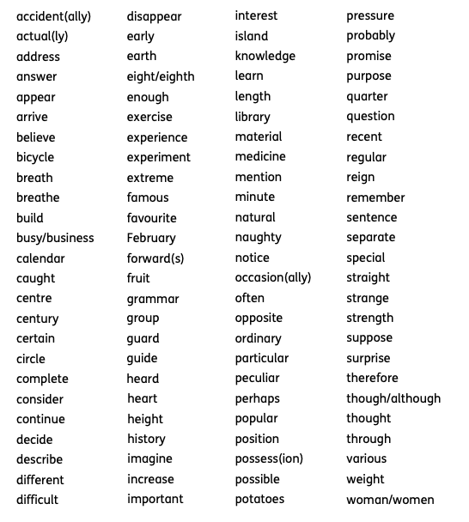
Here are the spelling words that children are expected to be able to spell by the end of year 4. (age 9)

