Division – Year Five
Essential Knowledge

Term | Definition |  | Example
Equal groups of | Give one object to each group
÷ Divide, division | Dividing into equal groups – give one to each numbered group in turn. |  | 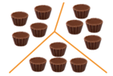
Divided by | Repeated subtraction from the dividend to group into the divisor |  | 12 divided by 4 = 3  12 – 4 – 4 – 4 = 0
Divided into | Sharing the dividend equally into the divisor |  | 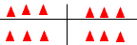
Remainder | The amount left over where one quantity cannot be exactly divided by another.  10 ÷ 3 = 3 remainder 1. |  | 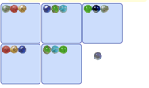  16 ÷ 5 = 3 R 1
Instructional Vocabulary
Number facts, |  | Number pairs, Number bonds
Greatest value |  | Least value
Term | Definition |  | Example
Factor | In multiplication the numbers multiplied together are called factors |  | Factor x factor = product  6 x 7 = 42
Quotient | In division the answer when a dividend is divided by the divisor the answer is the quotient |  | 42 ÷ 6 = 7  Quotient
Divisible by | When a number gives a whole number answer |  | 24 is divisible by 1, 2, 3, 4, 6, 8, 12, 24
Inverse | The opposite or reverse of an operation. Division is the inverse of multiplication |  | 6 x 9 = 54  54 ÷ 9 = 6
Remainders as fractions or decimals | When a number does not divide evenly into another, the leftover can be expressed as a remainder, fraction, or decimal |  | 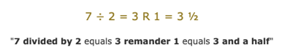  3 and a half = 3.5
Instructional Vocabulary
Calculate, work out, solve |  | Investigate, question
Answer, Check |  | Different missing number/s
Division facts for all tables | Division facts for 7 x table  2 x table 8 x table  3 x table 9 x table  4 x table 10 x table  5 x table 11 x table  6 x table 12 x table |  | Halve larger numbers and decimals |  | 2674 ÷ 2 = 1337  0.34 ÷ 2 = 17  74, 202 ÷ 2 = 37, 101
Apply place vale to derive division facts | 8 ÷ 2 = 4 therefore 0.8 ÷ 2 = 0.4  49 ÷ 7 = 7 therefore 49,000 ÷ 7,000 = 7  108 ÷ 12 = 9 therefore 10.8 ÷ 12 = 0.9 |  | Partition to divide mentally including decimals |  | 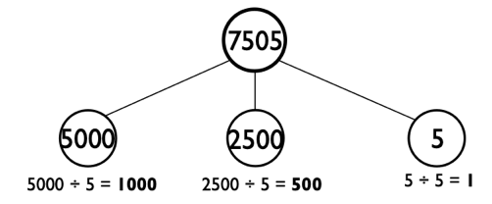  7505 ÷ 5 = 1501
Divisibility tests to 2, 3, 5, 6, 9, 10 | 2 Any even number (ending in 0,2,4,6,8) will divide equally by 2  3 Any number with a digit sum of a multiple of 3  5 Any number ending in 0 or 5 will divide equally by 5  6 Any number with a digit sum of a multiple of 3 and is even will divide equally by 6  9 Any number with a digit sum of a multiple of 9 and will divide equally by 9  10 Any number with ending in 0 is a multiple of 10 |  | Any number where last two digits are divisible by 4, will all divide by 4 | Example: is 45, 215 divisible by 4?  Test: 15 ÷ 4 = 3 remanider 3  So 45,215 is not divisible by 4.  Example: is 24,576 divisible by 4?  Test: 76 ÷ 4 = 19  76 divides equally by so it is divisible by 4.

