Term | Definition | Example
Lots of, groups of | Equal groups of amounts | 7 lots of 5 = 35
X, times, multiply, multiplied by | Combining sets of equal groups  Repeated addition | 5 + 5 + 5 + 5 + 5 + 5 + 5 = 35  7 lots of 5 = 35  7 x 5 = 5
Repeated addition | Counting equal groups in 2s, 5s or tens | 5 + 5 + 5 + 5 = 20
Product | The result of multiplying two numbers together | 4 X 8 = 32  product
Array | Rectangular arrangements to show equal groups | 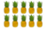
Term | Definition |  | Example
Column | Objects lined top to bottom.  Objects lines form left to right |  | Column. Row
Row
Double | Total of two sets of the same amount |  | Double 4
Half | Divide the amount into two equal sets. |  | Half of 8
Multiple | What is created after multiplying the number by a whole number. |  | 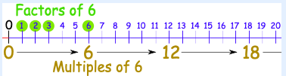
Factor | What is multiplied to get the number
Instructional Vocabulary
Carry on, Continue, Repeat |  | Describe the pattern, describe the rule
What comes next? Predict |  | What would we try next? How did you work it out?
Pattern, puzzle, |  | Number sentence, equation
Calculation, calculate, mental calculation |  | Sign, symbol, equation
Multiplication – Year Four
Previous tables learnt so far | 2 x table 5 x table  3 x table 6 x table  4 x table 8 x table |  | 9 x table | 1 x 9 = 9 7 x 9= 63  2 x 9 = 18 8 x 9= 72  3 x 9 = 27 9 x 9= 81  4 x 9 = 36 10 x 9 = 90  5 x 9 = 45 11 x 9 = 99  6 x 9 = 54 12 x 9= 108
10 x bigger | Understanding of place value to make numbers ten times bigger.  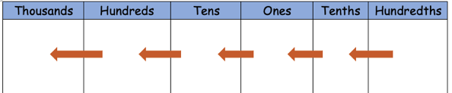  By multiplying by 10 the value of digits increases by 10. |  | 11 x table | 1 x 11 = 11 7 x 11 = 77  2 x 11 = 22 8 x 11 = 88  3 x 11 = 33 9 x 11 = 99  4 x 11 = 44 10 x 11 = 110  5 x 11 = 55 11 x 11 = 121  6 x 11 = 66 12 x 11 = 132
7 x table | 1 x 7= 7 7 x 7= 49  2 x 7 = 14 8 x 7= 56  3 x 7 = 21 9 x 7= 63  4 x 7 = 28 10 x 7 = 70  5 x 7 = 35 11 x 7 = 77  6 x 7 = 42 12 x 7 = 84 |  | 12 x table | 1 x 12 = 12 7 x 12 = 84  2 x 12 = 24 8 x 12 = 96  3 x 12 = 36 9 x 12 = 108  4 x 12 = 48 10 x 12 = 120  5 x 12 = 60 11 x 12 = 132  6 x 12 = 72 12 x 12 = 144

Essential Knowledge

