Year One
This week’s learning: 6th November 2020

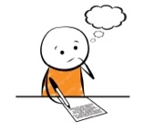  Spellings | Reading | 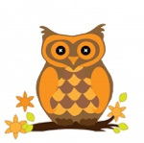  Vocabulary
cure  pure  fair  hair  year  fear  she  he | said  to  was  your  they  by  me  come | Spiky – something very pointed.  Huge– great in size, enormous, vast, very large  Crunchy– being firm and making a sharp sound when crushed  Delicious– giving great pleasure to your taste  Canopy – something high in the air that is spead out covering the earth.  DON’T FORGET TO READ YOUR READING BOOK EVERY DAY!  SHARE STROIES AND OTHER BOOKS AS OFTEN AS YOU CAN!

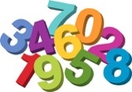  Maths  This Photo by Unknown Author is licensed under CC BY-ND | 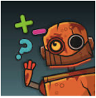  NumBot | Maths Vocabulary
Practice counting in 10s to 100  Practise writing numbers to 50 and saying how many 10s and 1s in the number eg 37 has 3 tens and 7 ones.  . | Colour in a smile each time you practise.  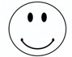 | Tens – the amount in the tens column. Each ten is worth 10 ones. We count 10,20,30…  Ones– The unit that is counted a 1 individual object. Each individual object is worth on and we count 1,2,3…

