Division – Year One

Term | Definition | Example
Count in ones, twos, tens | Say numbers in order jumping in sets. | 1,2,3,4,5,5,6,7,8,9,10,11,12,13…  2,4,6,8,10,12,14,16,18,20,22…  10,20,30,40,50,60,70,80,90,100
Share | Dividing into equal groups – give one to each numbered group in turn.
Groups of | Making sets of an agreed number e.g. 5
Equal groups | Making sets of equal groups
Odd | A number that cannot be divided into two equal groups | 5 is an odd number
Term | Definition |  | Example
Even | A number that can divided into two equal groups |  | 6 is an even number
Instructional Vocabulary
Count out |  | Share out
Left |  | Left over
Count back in twos | 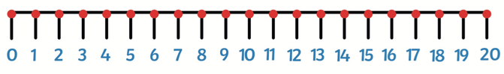  20 18 16 14. 12. 10. 8. 6… |  |  | Halves up to 10 |  | Half of 2 = 1  Half of 4 = 2  Half of 6 = 3  Half of 8 = 4  Half = 10 = 5
Count back fives | 50 45 40 35 30 25. 10... |  |  | Half mulitples of 10 |  | Half of 10 = 5 Half of 60 = 30  Half of 20 = 10 Half of 70 = 35  Hald of 30. = 15 Half of 80 = 40  Half of 40 = 20 Half od 90 = 45  Half of 50 = 25 Half of 100 = 50
Count back tens | 100 90 80. 70 60 50…  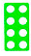 |  |  | How many 2’s? 5s? 10? | Grouping objects into sets of 2/ 5 or 10.  Count the number of sets – 6 groups of 2
All even numbers will divide by two | 10 divides by 2 | 6 divides by 2

Essential Knowledge

