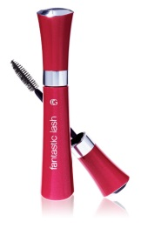**Alex Rider Gadget**

* **To be able to plan a report.**
* **To be able to write in note form.**

**You are a spy working for MI6 and have been asked to design a gadget which can be used by MI6’s rising star, Alex Rider.**

**You will have to create a gadget which is disguised as an ordinary, everyday object. You will need to consider the following questions:**

**[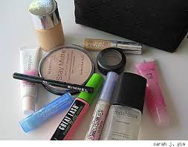](http://www.google.co.uk/imgres?imgurl=http://www.blogcdn.com/www.styledash.com/media/2008/04/sarahs-makeup-bag.jpg&imgrefurl=http://www.stylelist.com/2008/04/10/inside-a-drugstore-beauty-queens-makeup-bag/&usg=__e2p-FpssyV_DzOLr9OphJit2bQY=&h=335&w=425&sz=35&hl=en&start=15&itbs=1&tbnid=CD1O-LbYiqV7uM:&tbnh=99&tbnw=126&prev=/images?q=makeup+bag&hl=en&gbv=2&tbs=isch:1)What is the gadget?**

**It is a device which is able to see through solid objects (like buildings). It’s also a supersonic hearing invention, which can hear for a radius of five miles.**

**What is it disguised as? (What does it look like?)**

**[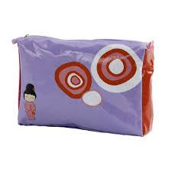](http://www.google.co.uk/imgres?imgurl=http://www.perfectinred.com/wp-content/uploads/wpsc/product_images/makeup-bag.jpg&imgrefurl=http://www.perfectinred.com/?page_id=40&usg=__jtJKXlgEbSoVvXnim9Ie26itktg=&h=400&w=400&sz=34&hl=en&start=12&itbs=1&tbnid=SKgLKLb-otZWqM:&tbnh=124&tbnw=124&prev=/images?q=makeup+bag&hl=en&gbv=2&tbs=isch:1)It’s disguised as an iPhone 5c.**

**What is it used for (function)?**

**The gadget is used to hear and see criminals for up to a radius of five miles**

**Why has it been designed and for whom ?**

**What special features has it got? (What makes this special?)**

**[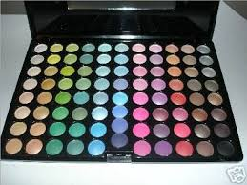](http://www.google.co.uk/imgres?imgurl=http://img.alibaba.com/photo/11118353/88_Professional_Eyeshadow_Palette.jpg&imgrefurl=http://www.sodahead.com/fun/if-you-could-only-wear-one-item-of-make-up-what-would-it-be/question-949800/?page=2&usg=__PGb8jnw1eXtiZ1rSwHM3WC6h9os=&h=300&w=400&sz=29&hl=en&start=1&itbs=1&tbnid=X6Tmv25Q1PYCvM:&tbnh=93&tbnw=124&prev=/images?q=eyeshadow&hl=en&gbv=2&tbs=isch:1)**

**Extra information (does anything need to be improved? Are there any things that the user will need to be aware/careful of – warnings-when using the gadget?).**

**The product has a fingerprint scanner installed on it which means that only the designated agent can use it.**

**[See full size image](http://decideforyourself.files.wordpress.com/2008/06/lipstick.jpg)In addition to this, the invention has a self-destruct button which will activate if somebody else tries to use it**

**How does the gadget work?**

**[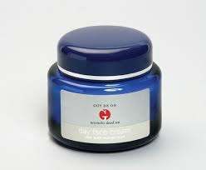](http://www.google.co.uk/imgres?imgurl=http://img.alibaba.com/photo/11783375/Dead_Sea_Face_Cream_With_Aromatic_Oils.jpg&imgrefurl=http://eglabs.trustpass.alibaba.com/product/11783375-11086475/Dead_Sea_Face_Cream_With_Aromatic_Oils.html&usg=__2idjtwpvf1gK53z65rGWiRBnowQ=&h=441&w=536&sz=34&hl=en&start=4&itbs=1&tbnid=qfSEmPNxNWvqdM:&tbnh=109&tbnw=132&prev=/images?q=face+cream&hl=en&gbv=2&tbs=isch:1)Explain to the MI5 board how the gadget works in a step by step guide (either bullet points or numbered instructions).**

**Include a labelled diagram**

1. **First of all, the agent will need to type into the phone the location which they want to investigate.**
2. **After this they wait for five seconds and then on the screen appears the image of whatever the spy is interested in.**
3. **This may be the interior of a building where criminals are meeting.**
4. **A button on the side of the phone should be pressed twice to enable the designated user to hear conversations which are happening in the place they have typed into the phone.**

**[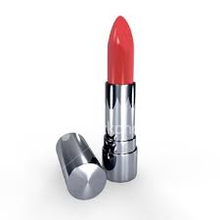](http://www.google.co.uk/imgres?imgurl=http://www.getentrepreneurial.com/images/red-lipstick.jpg&imgrefurl=http://www.getentrepreneurial.com/sales-marketing/marketing_mythology_putting_lipstick_on_a_pig.html&usg=__fazEWn2rRXJrie3JiX_JmfAxdkY=&h=380&w=380&sz=14&hl=en&start=1&itbs=1&tbnid=mo1L2sVvdgpjMM:&tbnh=123&tbnw=123&prev=/images?q=lipstick&hl=en&gbv=2&tbs=isch:1)**

**[](http://www.google.co.uk/imgres?imgurl=http://i46.photobucket.com/albums/f116/SportzBen314/floss.gif&imgrefurl=http://s46.photobucket.com/albums/f116/SportzBen314/?action=view&current=floss.gif&sort=ascending&usg=__yqot30ATEWoGCAZATOqODfWQIyY=&h=372&w=500&sz=5&hl=en&start=2&itbs=1&tbnid=77IhPkgWEGaX_M:&tbnh=97&tbnw=130&prev=/images?q=dental+floss&hl=en&gbv=2&tbs=isch:1)**